2D Angle Calculation Method for COCO Keypoints (Script A)
This document explains how Script A calculates joint angles using 2D COCO keypoints. It uses vector mathematics to compute angles at joints such as the elbow, knee, and trunk. Each keypoint is represented as (x, y, confidence), and angles are derived using vector operations.

Step-by-Step Example: Elbow Angle Calculation
Given COCO keypoints:
- Shoulder: (300, 200)
- Elbow: (350, 250)
- Wrist: (400, 300)
1. Form vectors from the elbow to adjacent joints:
- a = Shoulder - Elbow = (-50, -50)
- b = Wrist - Elbow = (50, 50)
2. Compute dot product:
- a · b = (-50)(50) + (-50)(50) = -5000
3. Compute magnitudes:
- |a| = sqrt(50² + 50²) ≈ 70.71
- |b| = sqrt(50² + 50²) ≈ 70.71
4. Compute cosine of angle:
- cos(θ) = dot(a, b) / (|a| * |b| + EPS)
- cos(θ) = -5000 / (70.71 * 70.71 + EPS) ≈ -1.0
5. Compute angle in degrees:
- θ = arccos(-1.0) = 180°
This indicates a fully extended arm (straight line).

Role of EPS in Angle Calculation
EPS (a small constant, e.g., 1e-8) is added to the denominator during cosine calculation to prevent division by zero.
This ensures numerical stability when vectors are very short or nearly zero-length.
Without EPS, dividing by zero or extremely small values could cause errors or inaccurate angle results.

Summary Table: Joint Angle Calculations
Joint | Keypoints Used | Vector Pair | Example Description
Elbow | Shoulder, Elbow, Wrist | Shoulder-Elbow, Wrist-Elbow | Fully extended arm gives 180°
Knee | Hip, Knee, Ankle | Hip-Knee, Ankle-Knee | Standing leg gives ~180°, bent leg < 150°
Wrist | Elbow, Wrist | Elbow-Wrist vs vertical | Straight wrist ~0°, bent wrist > 15°
Upper Arm | Shoulder, Elbow, Hip | Shoulder-Elbow vs trunk | Arm raised gives higher angle
Trunk | Shoulder Midpoint, Hip Midpoint | Shoulder-Hip vs vertical | Upright trunk ~0°, leaning > 10°
Neck | Nose, Shoulder Midpoint, Hip Midpoint | Head-Shoulder vs trunk | Neutral neck ~0°, bent > 10°

Trunk Angle Calculation
Measures torso lean from vertical using shoulder and hip midpoints.
Example:
Shoulder midpoint: (325, 225)
Hip midpoint: (325, 325)
Vector: (0, 100)
Angle to vertical: 0° (upright trunk)

Neck Angle Calculation
Measures neck flexion/extension relative to trunk using nose, shoulder midpoint, and hip midpoint.
Example:
Nose: (325, 200)
Shoulder midpoint: (325, 225)
Hip midpoint: (325, 325)
v1: (0, 25), v2: (0, 100)
Angle: 0° (neutral neck)

Wrist Angle Calculation
Measures wrist deviation from vertical using elbow and wrist.
Example:
Elbow: (350, 250)
Wrist: (400, 300)
Vector: (50, 50)
Vertical: (0, 1)
Angle ≈ 45°

Elbow Angle Calculation
Measures internal angle at elbow using shoulder, elbow, and wrist.
Example:
Shoulder: (300, 200)
Elbow: (350, 250)
Wrist: (400, 300)
Vector a: (-50, -50), Vector b: (50, 50)
Dot product: -5000
Angle: 180° (fully extended arm)

Knee Angle Calculation
Measures internal angle at knee using hip, knee, and ankle.
Example:
Hip: (300, 400)
Knee: (350, 450)
Ankle: (400, 500)
Vector a: (-50, -50), Vector b: (50, 50)
Dot product: -5000
Angle: 180° (fully extended leg)
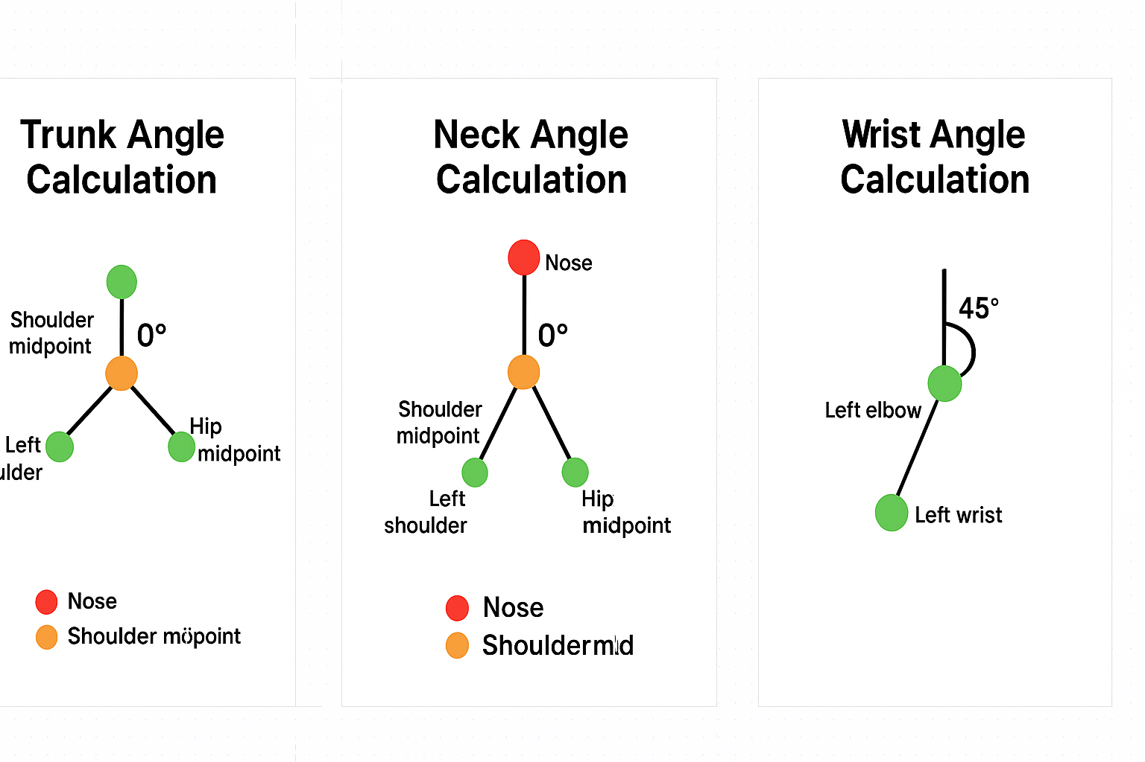
Script A Code: C:\Users\220250572\OneDrive - Regal Rexnord\Desktop\Ergonmics\ erg_eval_REBA_RULA_NIOSH_image_V6.py
Script B Code : : C:\Users\220250572\OneDrive - Regal Rexnord\Desktop\Ergonmics\ erg_eval_REBA_RULA_NIOSH_image_V5.py
Here's a detailed comparison between your first ergonomic evaluation script (let's call it Script A) and the second one (Script B), focusing on structure, angle computation, joint logic, and scoring methodology.

🔧 1. Angle Calculation Method
Script A:
- Uses angle_at_joint(p1, p2, p3) for internal angles at joints.
- Uses angle_between_vectors(v1, v2) for directional comparisons.
- Includes angle_to_vertical() to assess posture relative to vertical axis.
- Adds a small EPS to avoid division by zero.
Script B:
- Uses a single calculate_angle(p1, p2, p3) function for all angles.
- Simpler logic: computes angle at p2 using dot product.
- Adds 1e-6 to denominator for stability.
✅ Verdict:
Script A is more modular and robust, especially for ergonomic contexts where vertical alignment matters (e.g., trunk posture). Script B is simpler, but lacks directional nuance.

🧍‍♂️ 2. Keypoint Handling
Script A:
- Uses COCO-17 format with (x, y, conf) for each keypoint.
- Computes midpoints for shoulders and hips to better represent trunk and neck.
- Uses vector() abstraction for clarity.
Script B:
- Uses only (x, y) without confidence scores.
- Directly maps keypoints without midpoints.
- Assumes left-side joints only.
✅ Verdict:
Script A is more anatomically accurate, especially for trunk and neck angles. Script B is faster, but may misrepresent posture if one side is occluded or misdetected.

📐 3. Angle-to-Score Mapping
Script A:
- Uses custom thresholds for REBA and RULA scoring.
- Trunk, neck, leg, arm, wrist scores are mapped based on ergonomic literature.
- Includes coupling, load/force, and activity scores.
Script B:
- Uses simplified thresholds, slightly different from Script A.
- Coupling score is hardcoded as 1.
- Load/force and activity scores are passed in.
✅ Verdict:
Script A is more flexible and configurable, while Script B is minimalistic and may need tuning for real-world use.

📊 4. Output Structure
Both scripts return:
- Angles per joint.
- Scores per joint.
- Total score and inference.
Script A also returns:
- Raw keypoints (kp) and separates REBA/RULA logic more cleanly.

📦 5. NIOSH Evaluation
Identical in both scripts. No difference.

🧠 Summary Table
Feature | Script A (Detailed) | Script B (Simplified)
Angle Calculation | Modular, directional | Single function
Keypoint Handling | Uses midpoints, confidence | Direct mapping
Scoring Logic | Ergonomically tuned | Simplified thresholds
REBA/RULA Separation | Clear and modular | Mixed logic
NIOSH Evaluation | Same | Same
Flexibility | High | Moderate
Speed & Simplicity | Moderate | High

✅ Recommendation
If you're aiming for production-grade ergonomic analysis, especially for your smart factory use case, Script A is the better foundation. It’s more accurate, modular, and extensible (e.g., for bilateral analysis or dynamic posture tracking).
Would you like help refactoring Script B to match Script A’s robustness, or perhaps merging the best of both into a unified ergonomic toolkit?

